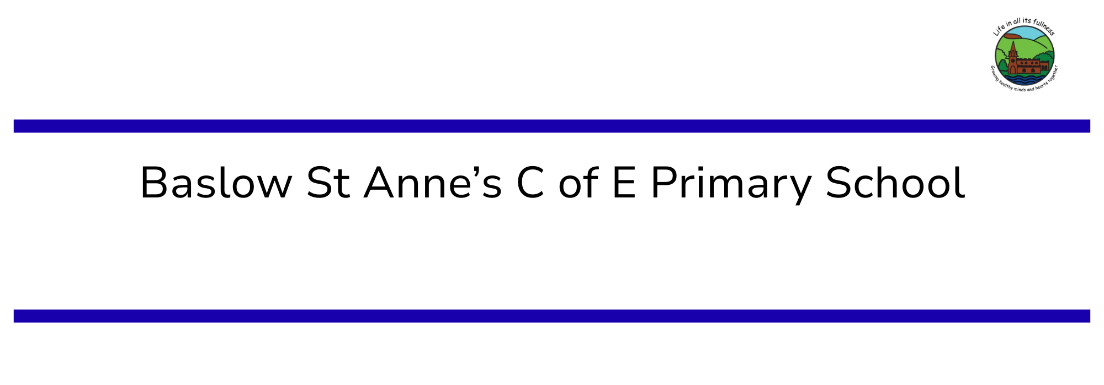

Music Policy

This policy is rooted firmly in our desire to fulfil our Vision to enable us to continue
‘Living Life in All Its Fullness’ (John 10:10)

Policy: | Music
Written and Agreed by: | Miss Grant and Headteacher
Date Written: | July 2026
Approved by and date:
Review Cycle: | Bi-annually
Next review due by:

We are proud to be a Lead School for Music with the Derbyshire Music Hub, supporting other schools and championing best practice across our area.

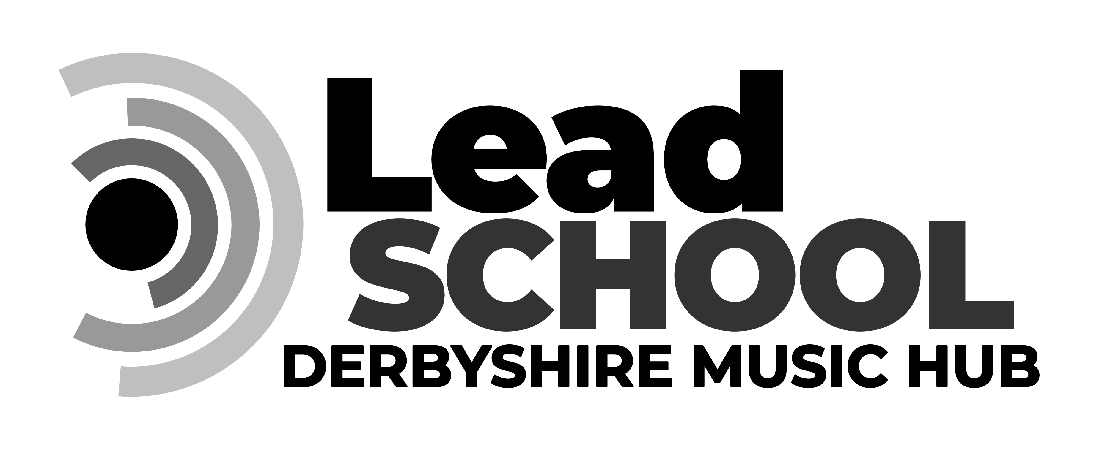

Vision Statement
Growing healthy minds and hearts together
by…
- Embracing Christian values
- Celebrating difference and uniqueness
- Maximising potential through effort, hard work, positivity, determination and perseverance
- Developing kind, respectful citizens and building skills for the future
- Challenging ourselves and finding inspiration in others
- Recognising and understanding physical and mental wellbeing

Mission
At Baslow St. Anne’s Church of England Primary School, we believe that it is vitally important that everybody is safe, confident and happy in our school community. We aim to provide an environment in which our children feel safe, secure and confident, are respectful citizens in and out of school and nurture the Christian that underpin all that we do. We believe that our children and staff should lead ‘a life in all its fullness’, nurturing our vision of growing healthy minds and hearts together. We strive to ensure this is in place to enable every child and staff member to achieve their full potential and be prepared for their next step in life.

Our Core Values

Respect
Treating everyone with kindness, listening to each other, and helping make our classrooms a safe and happy place to learn together.
“Love one another with brotherly affection. Outdo one another in showing honour.” Romans 12:10

Kindness
Learning respectfully alongside each other, helping each other to grow through our acts of kindness.
“Do for other people the same things you want them to do for you.” Matthew 7:12

Diversity
Making sure every person feels safe, welcome, included and valued.
“Live in harmony with one another.” Romans 12:15
“Accept one another, then, just as Christ accepted you, in order to bring glory to God.” Romans 15:7
“Love your neighbour as yourself.” Mark 12:31

Purpose of the Music Policy

▪ Give every child the opportunity to experience enjoyment through a variety of musical
activities and to respond to musical emotions.
▪ Help children of all abilities develop positive attitudes and to experience success and
satisfaction in music.
▪ To perform, listen to, review and evaluate music across a range of historical periods, genres, styles, and traditions, including the works of great composers and musicians.
▪ Develop an understanding of musical traditions and enhance performance skills by
learning and performing music in a variety of cultures.
▪ To learn to sing and to use their voices, to create and compose music on their own and with others, have the opportunity to learn a musical instrument, use technology appropriately and have the opportunity to progress to the next level of musical excellence.
▪ To offer wider opportunities through 1:1 music tuition by peripatetic music teachers from Derbyshire Music Partnership.
▪ Provide an array of performance opportunities so children can feel part of a community.
▪ Encourage children to express ideas and opinions about music.
▪ To encourage all children to develop a passion and love for music and musical experiences and offer opportunities for all.
▪ To develop and enrich subject specific vocabulary to help them understand and discuss
their own work and that of others.
▪ To be read in conjunction with our Music Development Plan 2026-2027.

Teaching and Learning
Music is a universal language that embodies one of the highest forms of creativity. Music teaching will engage and inspire pupils to develop a love of music and their talent as musicians, and so increase their self-confidence, creativity and sense of achievement. Our planning for Music, follows the revised National Curriculum for Music guidelines September 2014, the Early Years Framework and the Model Music Curriculum. We follow the Kapow music scheme enhanced through a variety of resources including Twinkl, Oak Academy and DMC resources. Music is taught weekly in all years as well as a whole school singing assembly in which the children also learn about genres of music composers. Year 4 have lessons through the Whole Class Instrumental Project where they learn violin with a professional teacher from DMC. We recognise the importance of constantly revisiting learning and use Kapow to ensure a repetitive and spiral learning scheme is being taught. Our learning environments encourage children to return to past learning regularly so that they can embed key concepts, skills and knowledge. Hands on activities are favoured. Children may not always record their learning formally as we value a wide range of learning opportunities such as composing, appraising and performing music. We have an Arts Corridor with many musical books which children are encouraged to explore and discover. We have many musical resources which are stored in our Kingfisher Room and Outdoor Classroom. Resources are reviewed and restocked regularly by the Music Lead.

Inclusivity and Accessibility
At Baslow St Anne’s C of E Primary School, we are committed to providing a fully accessible environment which values and includes all pupils, staff, parents and visitors regardless of their education, physical, sensory, social, spiritual, emotional, and cultural needs. Through our vision of life in all its fullness, we are passionate about an inclusive music provision.
We design our own units of learning, customising them to meet the needs of our pupils; including those who have learning difficulties and those who are gifted and talented. This ensures our teaching and learning meets the demands and interests of the full range of learners and keeps pace with changes. We challenge stereotypes and mitigate bias through the careful selection of resources and discussion areas.

Assessment
Work for each half term is planned on half termly forecasts with activities in line with the NNC guidance and outcomes. At the end of each unit, teachers evaluate the outcomes. As much of the work done is practically, the most appropriate way of assessing is through discussion, observations and talking to the children which also helps children to make self-evaluations. The Kapow assessment tool helps to review and reflect on a child’s learning at the start and end of modules. Where gaps are shown, teachers reflect on this in their planning so that these missing elements can be retaught. Individual comments and data will be written on end of year reports to reflect pupil progress in this subject. Evidence of standards in music are recorded where appropriate in photo, audio and visual form.
Peripatetic tutors hold their own records and liaise with parents as well as the Music Lead.

Extra-Curricular
We provide all children in KS1 and KS2 with the opportunity to join the school choir. Rehearsals are held weekly and regular performances are given in the community. We also participate in Young Voices and other local festivals and competitions. In addition, all Church services and our Infant and Junior productions contain a large amount of music. We sing every day in Collective Worship and individual instrumentalists often perform as the children arrive in the hall. We frequently seek opportunities for professional musicians to visit as well as taking part and watching performances including Hallé, Concerteenies and our annual Summer Musical Evening. We have many music clubs at lunchtimes and after school including Music Theory, Recorder Boppers, Musical Theatre and our new School Orchestra. We currently offer peripatetic lessons in: woodwind, brass, string, keyboard, voice and drum lessons.

