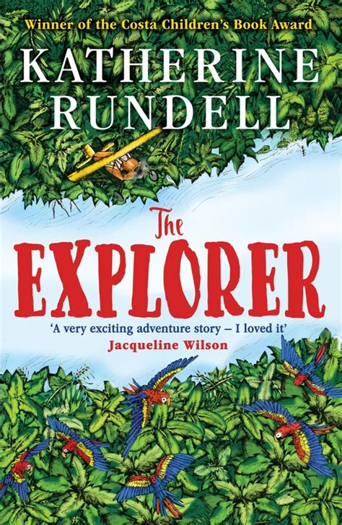
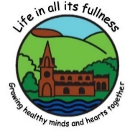
Curriculum Map Class 5 Year 6 Autumn 1 2026
As Technology users we will:
- Learn steps to help ourselves stay safe online
- Understand the consequences of posting online
- Know how to deal with negative experiences online

As Scientists we will:
- Use classification to sort animals
- Find out about Carl Linnaeus
- How animals have adapted to their habitats
- Evolution
- Fossils

As Geographers we will:
- Investigate what it would be like to live in the desert
- To summarise the characteristics of a desert biome.
- To locate and explore features of deserts.
- To describe the physical features of a desert environment.

As Foreign Affairs Correspondents we will:
- Improve our Spanish vocabulary through the art of conversation
- Numbers to 30

As Design Technologists and Artists we will:
- Create art in sketch books
- Use a variety of materials and techniques to create meaningful artwork linked to our school values
- Use art as mindfulness
- Indigenous global art inspiration
- Research artists and street art inspiration

As Active Individuals we will:
- Build on coordination skills and cardio through circuit training
- Develop our skills in Netball

As Well-Rounded Citizens we will:
- Continue to develop our British Values of democracy and mutual respect
- Learn about the 5 Ways to Wellbeing
- Learn how to keep ourselves healthy

As Mathematicians we will:
- Understand and use mathematical symbols
- Using and applying mathematical knowledge
- Use maths in real life situations
- Demonstrate mastery through explanations
- Learn how to read and use coordinates
- How to recognise different units of measure

As Historians we will:
- Research the lives of real-life explorers and survivors

As Religious Investigators we will:
- Learn about how do Christians live and What Jesus would do
- Recognise what spirituality means to us

As Readers and Writers we will:
- Read The Explorer by Katherine Rundell
- Develop reading comprehension skills
- Learn to identify what makes an effective non-chronological report
- Understand how characters can be conveyed through the use of dialogue
- Learn to write a narrative from the point of view of a character
- Create a Tanka

As Musicians we will:
- Learn to sing a song maintaining melodies and exploring harmonies for a final performance

As Historians we will:
- Look at how farming has changed over time

